Date: | 18 July 2025
Email: | democraticservicesteam@huttcity.govt.nz
Subject: | Rate Instalment Changes

Tēnā koutou katoa,
We received an email from Cr Brady regarding Rate Instalment Changes.
The response from officers follows:
We have arranged for the webpage to be updated with information about how to access the new annual rates figures.
The new annual rates for all properties is available now on our website from the Property Search page: https://www.huttcity.govt.nz/property-and-building/rates-and-aluations/property-search
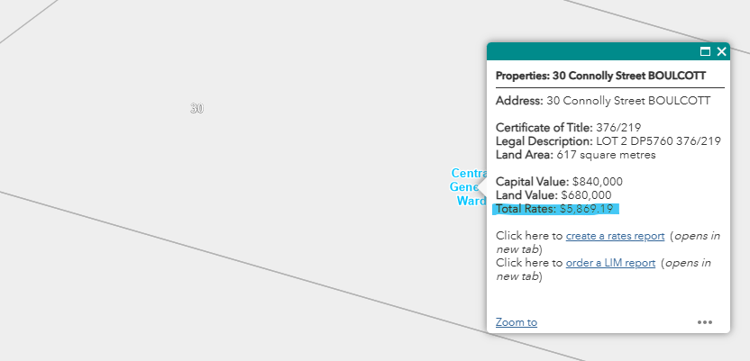
Invoices will be sent around 1 August, with emailed invoices received immediately and posted invoices taking a few days to arrive. This invoice will be due for payment by 1 September. Ratepayers are invited to contact the Rates team with any concerns about their ability to pay the instalment in full by the due date. Weekly, fortnightly and monthly direct debits are encouraged, and the rates team is happy to help with payment arrangements.

Ngā mihi nui,
Democratic Services Team

