Date: | 4 September 2025
Email: | democraticservicesteam@huttcity.govt.nz
Subject: | Cricket at Petone Recreation

Tēnā koutou katoa,
We received an email from Cr Dyer regarding cricket at Petone Recreation Ground.
The response from officers follows:
Thank you for this enquiry. It should be noted that Cricket Wellington is fully engaged in this project. Officers have made multiple attempts to engage with Riverside Cricket Club. As of the end of last week, no response had been received. However, officers heard back from the club this morning and have scheduled a meeting with them.
As part of the current Long Term Plan Council has invested in a programme of improvements to sports field drainage. The programme was approved by the Communities, Culture and Partnership Committee on 20 November 2023 and included in the Parks and Reserves work programme, which was approved by the Committee in June this year. This programme includes work on the Petone Recreation Ground between 2024-27. Similar works were completed last year at Richard Prouse Park, Naenae Park, and Hutt Park. The work has come about in response to concerns raised by the community about the condition of grounds, including in submissions to the LTP.
The project at Petone Recreation Ground involves:
- Installation of subsoil drainage across the entire ground
- Removal of one clay cricket block and renewal of a second clay block
- No impact on artificial training nets
As part of this project, officers reviewed the two existing clay cricket blocks (pitches 3 & 4). Over time, these blocks have been raised significantly through repeated clay top-ups. Their current height now poses a health and safety risk as they are located on rugby fields and act as a trip hazard. In addition, the blocks require re-grading to ensure the new subsoil drainage functions correctly. Officers found that blocks were not originally constructed to standard and would need to be fully renewed to achieve the required outcome. However, within the available budget, only one clay block can be renewed. The new block will be of a much higher specification than the existing ones and will provide six new clay strips.

Renewing a clay block costs approximately $90,000 each, with additional ongoing maintenance requirements. Officers met with Cricket Wellington last week to discuss the scope of the upcoming project and the reasons why only one block could be renewed. While disappointed at the loss of one block, Cricket Wellington acknowledged that the new block would provide a much higher-quality facility. Officers also discussed plans to hybrid-stitch one of the cricket strips at Petone Recreation Ground, which will further improve quality and durability, allowing more games to be played.
It is important to note that the Nuku Ora Regional Sports Fields Report (2023) indicated that Hutt City currently has, and is projected to continue to have, a surplus supply of cricket wickets compared with other councils in the region.
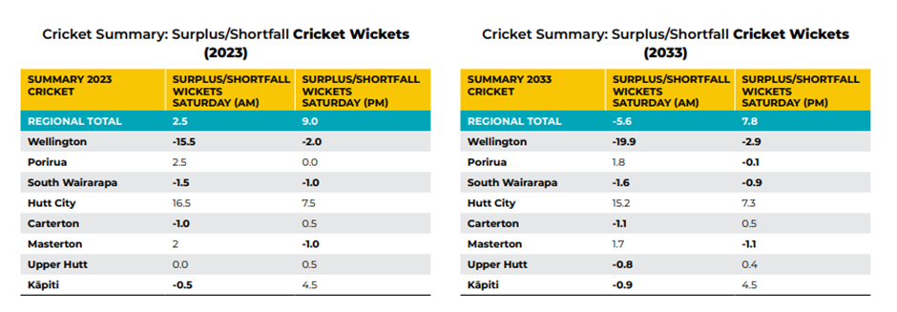
It further stated:
“While the modelling suggests that there are sufficient wickets to meet demand, the quality of a number of these is poor, with pitches in poor condition and not considered safe for play.” (Page 21)
By installing a new, improved block, officers are addressing the issue of quality, in line with this recommendation.
This decision has been guided by the need to deliver projects within approved budgets, particularly given the current financial pressures and the need for Council to achieve savings. Cricket is one of the most heavily subsidised sports, requiring significant operational investment to maintain clay blocks. Reducing the number of blocks will help lower ongoing operational and renewal costs, while still providing a higher-quality playing surface for users.
As noted, officers advised Cricket Wellington (through Matt Wilson) of the project earlier this year, and further engagement has taken place recently to confirm scope and timelines. Officers have made multiple attempts to engage with Riverside Cricket Club.
The project is scheduled for completion by the end of this year. As cricket clay blocks do not usually come into use until November, the programme has been designed to minimise disruption, with the ground expected to be available for play again in January 2026. Officers are committed to working closely with affected groups to assist them during the delivery of this essential project.

Ngā mihi nui,
Democratic Services Team

