BOULCOTT MEMORIAL
PROJECT REPORT

22 August 2023

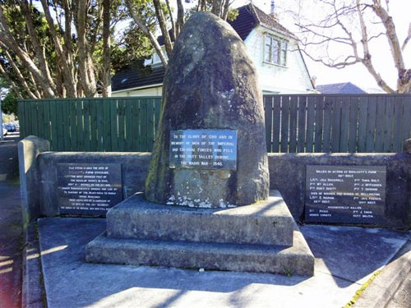

Prepared by:
Dr Liana MacDonald
Dr Vincent O’Malley
Professor Joanna Kidman
Contents

Introduction 2
Historical background 3
Recommendations 3
Research learnings and process 5
Project team 7
Appendix A: Ngā kaipūrākau 7
Appendix B: Historical context 13
Appendix C: Findings from oral history interviews 18
Appendix D: Kaipūrākau recommendations 29

Introduction
This report presents research commissioned by the Hutt City Council (HCC) investigating various Māori and Pākehā perspectives about the battle of Boulcott’s Farm to inform recommendations about how the Boulcott memorial may be adapted to acknowledge a wider view of all groups involved in the conflict.

This research was commissioned as a response to concerns by members of the Te Awa Kairangi ki Tai Lower Hutt community that the current memorial does not accurately reflect those parties’ perspectives that were involved in the event it relates to.

Between the months of March and July 2023, kaipūrākau (representatives of each group involved in the research) from Ngāti Tama, Ngāti Rangatahi, Ngāti Toa, Te Ātiawa, Ngāti Hāua and descendants of Almon Boulcott, were interviewed by primary researcher Dr Liana MacDonald about the battle and other histories and relationships that related to this significant event. (See Appendices for further information about these narratives and the representatives involved in the project). Kaipūrākau responses have then been collated in this report including specific feedback related to the recommendations and themes from the various narratives collected.

Historical background
The battle of Boulcott’s Farm was fought at the site of a British military post in the Hutt Valley on 16 May 1846. It was the result of hostilities arising out of the New Zealand Company’s disputed land purchases in the region and the decision of Governor George Grey to declare martial law and evict all Māori living in the Hutt Valley. In the 1920s a memorial was erected on the corner of High Street and Military Road to the British soldiers who died during the battle. (See Appendix B for an historical account of the battle and the history of the memorial).

Recommendations
Kaipūrākau were asked to provide feedback on four possible options related to the current Boulcott Memorial (See Appendix D for specific iwi recommendations):
- Remove or update the existing memorial
- Retain the existing memorial but add information panels that explain the wider historical context
- Erect a new memorial that acknowledges a tangata whenua perspective of events
- An alternative form of remembrance and dissemination of perspectives

Also included are recommendations that might help to provide some guidance about how HCC may work towards a more robust research process that could assist with future projects of this nature.

Recommendation 1:
Feedback from the groups indicate a majority consensus to keep the existing physical memorial in its current form and location. However, kaipūrākau would like to see additional information included in the immediate vicinity that contextualises the battle of Boulcott’s Farm within a wider narrative reflecting Māori social and cultural perspectives (See Appendix C for the themes that emerged from interviews with iwi).

It is suggested that interpretive panels could be placed in relation to the current memorial. Although the themes in this report highlight the depth and complexity of Māori history, the number of words on the panel should be succinct. The panel writer(s) can exercise restraint and care by ensuring that some events are kept open to multiple interpretations, given that there are contested versions of the history.

There are benefits to keeping the plaques in their current location as these, too, provide context about the evolving nature of national remembrance and identity. Internationally, this approach has been adopted in response to many contentious or controversial monuments or memorials in recent years, with the additional panels installed at such sites often referred to as contextual markers (because they provide historical context missing from the original wording).

Recommendation 2:
As a result of this project, it was identified that further, sustained engagement with iwi is needed to ensure the content of the interpretive panels reflects the diversity of perspectives. Many of the iwi kaipūrākau and the Te Ātiawa research assistant involved in the project expressed willingness to continue working on this project with HCC, therefore a rōpū of iwi representatives could be formed for this purpose. The descendants of Almon Boulcott would also like to be kept updated with progress towards any changes to the memorial. Perhaps open-door community and iwi wānanga could also be arranged to elicit feedback about the content of the interpretive panels.

Recommendation 3:
Kaipūrākau suggested other options for how this critically important event can be better represented and made accessible beyond the information at the physical site of the memorial. Digital options such as a website or app might offer a good way for diverse iwi perspectives and stories to be accessed. A QR code on the information panel might direct visitors to the memorial to a website where they can learn about this history and the various iwi perspectives on it.

Recommendation 4:
Develop a framework and guidelines for research projects of this nature (particularly iwi centered community research) conducted or contracted by Hutt City Council.

It was identified as a result of the contracting and research process that there were a number of aspects related to this project that neither Victoria University of Wellington or Hutt City Council had encountered or considered including the ethics of data collection and storage, kaipūrākau consents processes, the length of time required for kaipūrākau to consult with whānau and hapū, the forums in which iwi centered research may need to happen such as wānanga and koha to acknowledge kaipūrākau involvement.

Recommendation 5:
The interviews data is currently being carefully stored by the research team and HCC. Each kaipūrākau indicated on the research project consent form whether the interview content should or shouldn’t be available to the general public and if the interview data should be stored with HCC and/or iwi archives. Given the recommendation that HCC and iwi representatives continue to work together to update the Boulcott memorial, the project team advises that the interview data remain private and confidential with HCC until the next sitting with iwi. At this point, the interview data collected from the Boulcott Memorial research project may be used when firm decisions have been made about how to update the memorial and other forms of remembrance (for example, multiple perspectives of the battle made available through the HCC website).

Research learnings and process
A research team consisting of three Victoria University of Wellington academic staff were engaged by a Hutt City Council project team based on an initial EOI process. Over the period of the project including the contract negotiations, undertaking the primary research and the collation and analysis primary researcher Dr Liana MacDonald made a number of observations outlined below:

Research learnings
- The initial timeline drafted by the research team proved too ambitious for the nature of an iwi-centered community research project. When negotiating the contract with HCC, Dr MacDonald estimated her time on the research at 30 days or 240 hours, however in retrospect thinks she committed twice this amount of time to the project.

- The project expectations between HCC and branches of VUW (Human Resources, UniVentures, Human Ethics Committee) were carefully worked through in the contract for services. For example, a standard Intellectual Property clause posed by VUW Human Resources was unsuitable for protecting the mātauranga (knowledge) of iwi communities and needed to be reworked. Additionally, a member of the Human Ethics Committee was involved in the contract for services negotiations to establish new data sovereignty and storage processes to ensure that mātauranga-a-iwi was protected across the various research groups.

- Numerous email exchanges, phone calls and kanohi-ki-te-kanohi (face to face) hui took place before the data collection sessions, thereby deepening relationships and trust between the researcher and prospective iwi participants.

- The date, time and method of each oral history interview was determined by each group. Related to the previous key learning, delays to data collection are likely when participants are actively involved with community matters and should be responded to accordingly. For example, one participant was unable to share their oral history during February-March as planned because they were busy packing and sending care packages to whānau in Hawkes Bay in the wake of Cyclone Gabrielle.

- Another significant episode of research co-design occurred when Te Ātiawa representatives requested that an iwi member lead the oral history interview process. In response, the project created an additional research assistant position that was funded through a VUW Mātauranga Māori Research Fund grant. The Te Ātiawa research assistant applied research methods underpinned by the histories and tikanga of his whanaunga.

- Two iwi groups spoke about the project providing a suitable form of acknowledgement for their time and mātauranga. In response, the HCC offered each group a koha of $2,000 to disseminate to a rūnanga or organisation for their involvement in the project.

- The research project involved strong Māori representation and was responsive to the cultural complexities and challenges of working with multiple groups who hold different political and historical viewpoints. For example, councillor Tui Lewis provided the groundwork for building relationships with various iwi groups. Karl Chitham and Emily Campbell worked closely with the lead researcher to provide cultural input at various stages, including contract negotiations, wānanga support and financial renumeration with iwi groups. The research team utilised their experience and background to successfully engage all groups; for example, shared whakapapa between the lead researcher and iwi participants also assisted the research process. Additionally, the VUW Kaiarahi Rangahau Māori was pivotal to securing the Te Ātiawa research assistant funds, and provided more money than was initially sought to accommodate a full salary, and wānanga and koha costs.

Research process
- After the expression of interest for the Boulcott Memorial project being selected as the preferred contractor in June 2022, the contract for services took three months to negotiate and was signed in September 2022. The research was approved by the VUW Human Ethics Committee in October 2022.

- HCC sought iwi participant involvement through the Quarterly Mana Whenua Partnership Hui during November and December 2022. The descendants of Almon Boulcott confirmed their involvement in January 2023 and prospective participants from each iwi group provided by councillor Tui Lewis were approached in February 2023.

- The data collection occurred across the months of March – July 2023. An amendment to the ethics application and a variation to contract for services was approved in April 2023 to account for the greater time required to complete the project appropriately. Two research assistants were also employed during this time.

Group | Date of data collection | Oral history method + duration
Ngāti Tama | 18 March 2023 | Initial wānanga and site visits (six hours)
Boulcott whānau | 22 April 2023 | Site visits (three hours)
Ngāti Rangatahi | 11 May 2023 | One wānanga (one hour)
Ngāti Toa | 18 May 2023 | One wānanga (two hours)
Te Ātiawa | 8 June 2023 | Three wānanga (three hours)
Ngāti Hāua | 6 July 2023 | Wānanga and site visits (six hours)

Project team
The research team has many years’ experience working with Māori communities and in conducting oral interviews and is committed to working with iwi in a culturally responsive manner. A culturally responsive approach advocates Kaupapa Māori research relationships built on mutual trust, respect, reciprocity and whanaungatanga (Smith, 2015), and a collaborative research process. The project team are:

Victoria University of Wellington:
- Dr Liana MacDonald (Ngāti Kuia, Rangitāne o Wairau, Ngāti Koata). Senior Lecturer Victoria University of Wellington. Lead Researcher.
- Dr Vincent O’Malley (MRSNZ FRHistS). Research Director HistoryWorks Limited. Archival Researcher.
- Professor Joanna Kidman (Ngāti Raukawa, Ngāti Maniapoto, Ngāti Toa Rangatira). Professor of Māori Education Victoria University of Wellington. Research and Cultural Advisor.
- Hami Love (Te Ātiawa). Te Ātiawa Research Assistant.
- Karenza Haapu (Ngāti Pāhauwera). Research Assistant.
- Kartik Nagarajan, Relationship Development Manager, Research Wellington UniVentures.

Hutt City Council:
- Andrea Blackshaw. HCC Director Neighbourhoods and Communities. Project Sponsor.
- Karl Chitham (Te Uriroroi, Ngā Puhi) HCC Head of Arts & Culture. Project Manager.
- Emily Campbell (Ngāti Porou). HCC Pou Whakamahere Kaupapa Here. Cultural Advisor.

Appendix A: Ngā kaipūrākau
Ngāti Tama
Greg White
Rīana Te Uira White-Haverkamp
Rae-Hinerau Wetere
Susan White
Pandra Reihana
Te Amoroa Clifton
Richard McClutchie

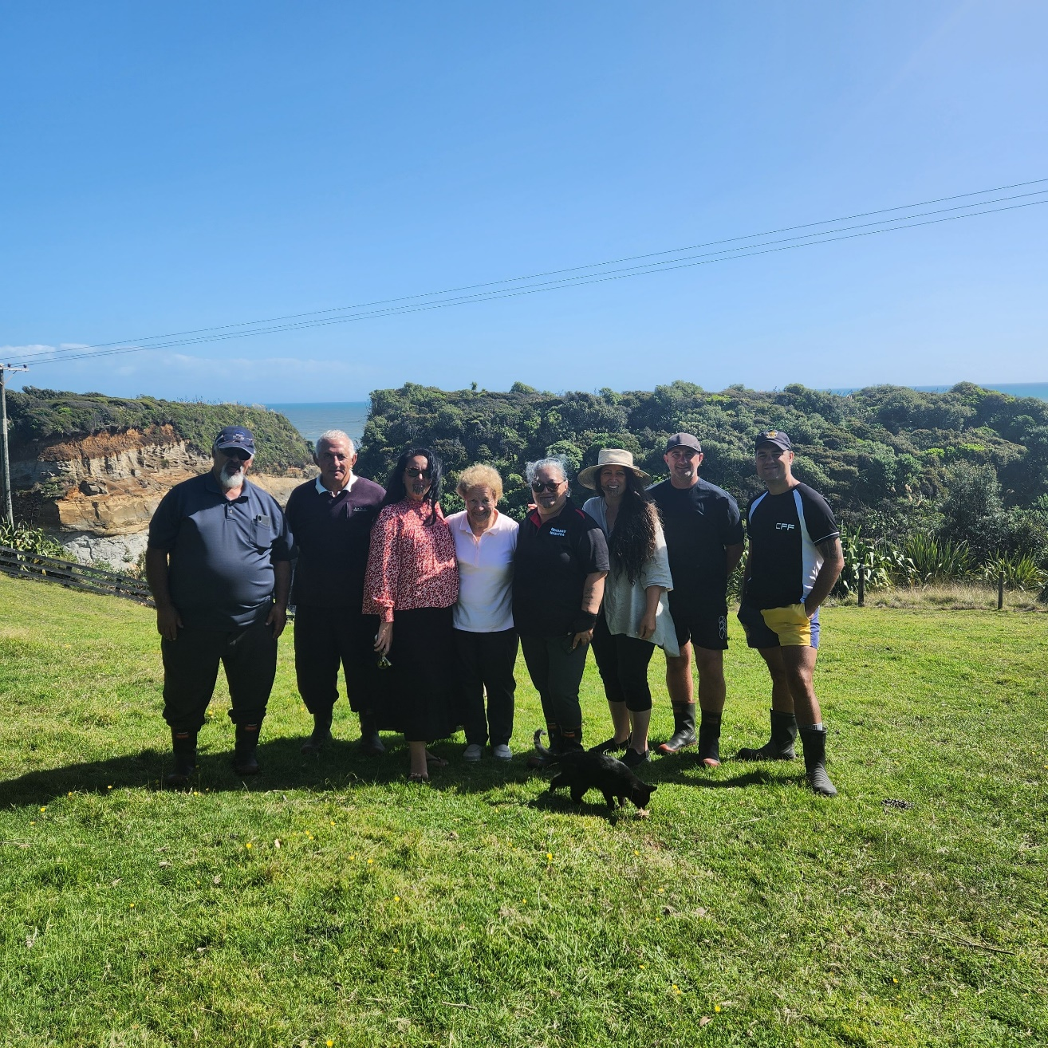

Descendants of Almon Boulcott
Roger Boulcott
Natasha Boulcott
Natalie Kelly
Maryann Carling
Allan Boulcott

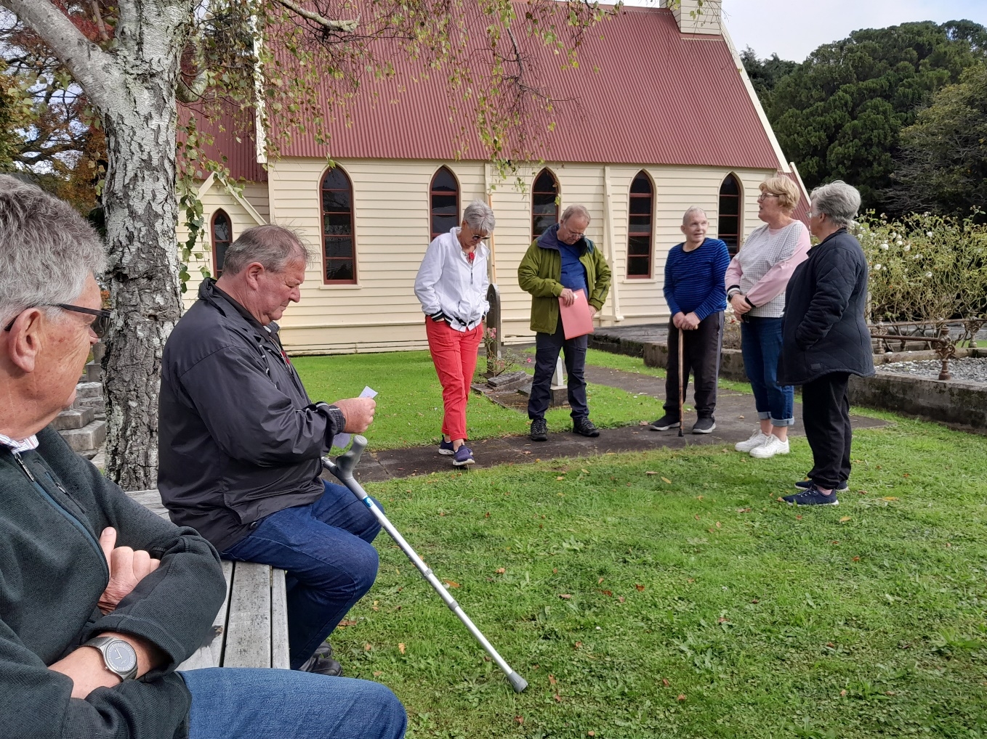

Ngāti Rangatahi
Hon Sir Edward Taihākurei Durie KNZM

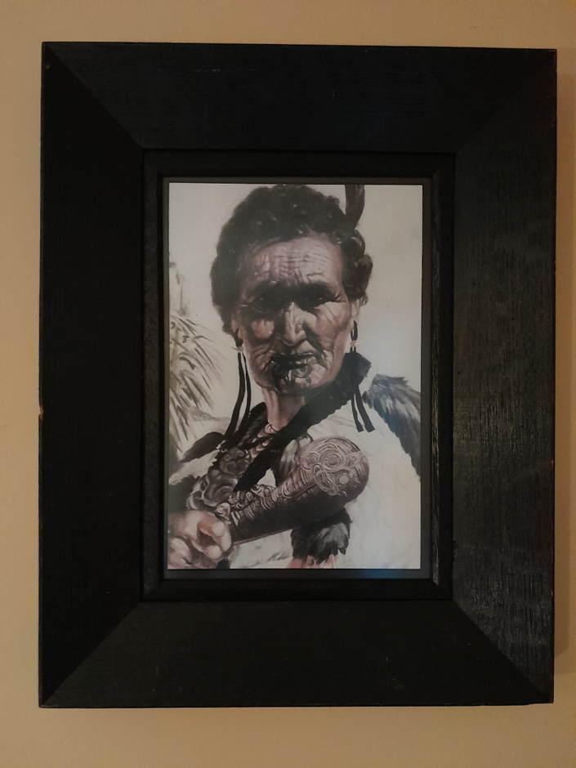
Ngāti Rangatahi rangatira, Mihikiturangi (Taihākurei Durie’s great grandmother)

Ngāti Toa
Dr Taku Parai
Te Rauparaha Horomona
Hohepa Potini

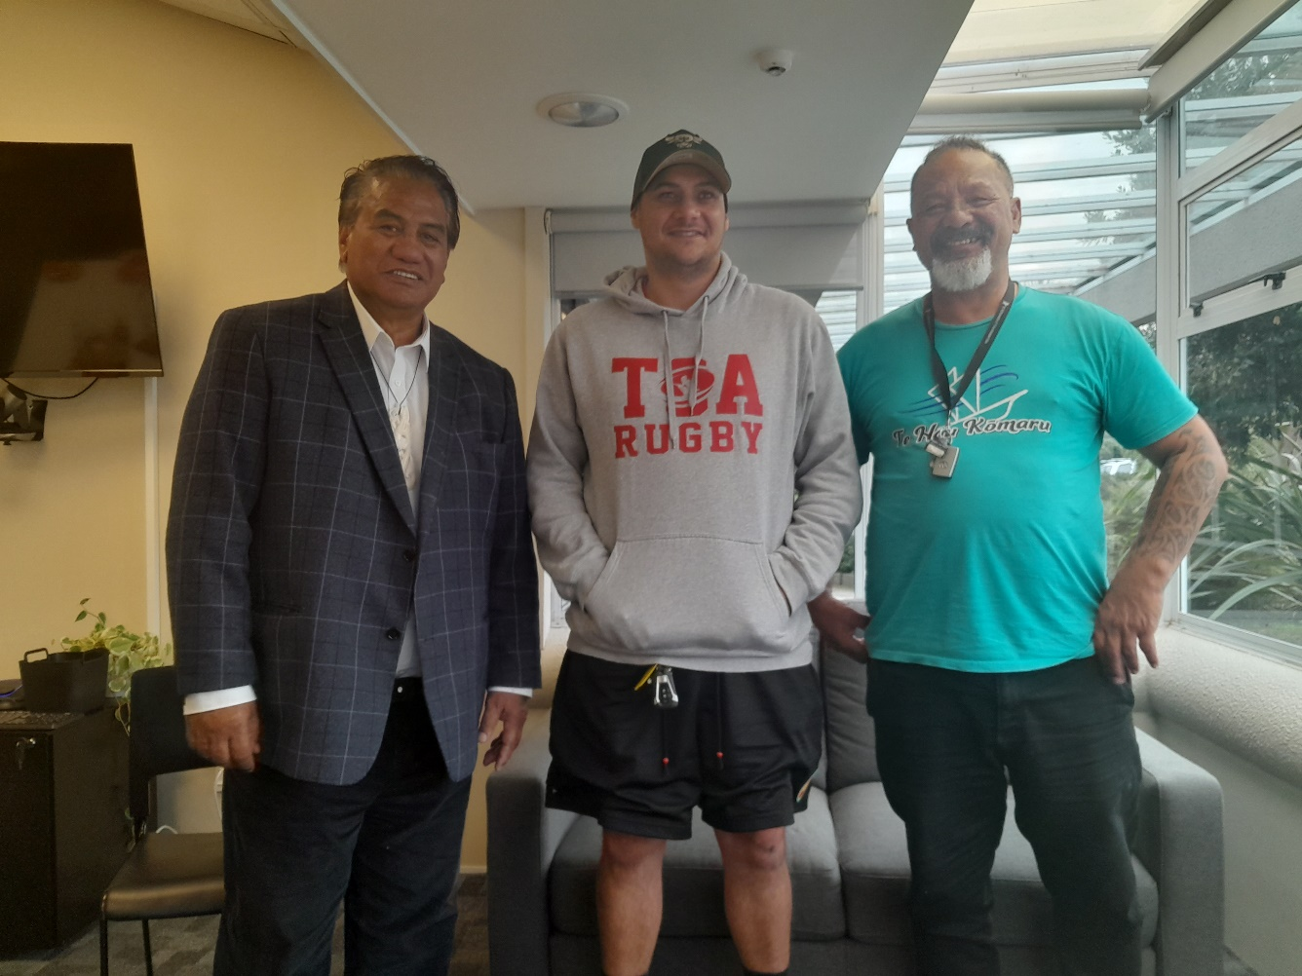

Te Ātiawa
Liz Mellish
Honiana Love
Dr Cath Love
Ihaia Puketapu
Hami Love

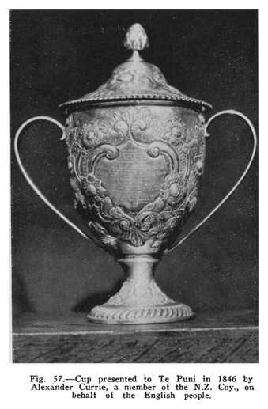

Retrieved from https://nzetc.victoria.ac.nz/tm/scholarly/WarEarl-fig-WarEarl175b.html

Ngāti Hāua
Piki Anderson

Appendix B: Historical context
This appendix provides brief historical context relating to the events the Boulcott Memorial commemorates, along with the history of the existing memorial itself. A list of sources is provided at the end of this section.

In the Wellington region, the New Zealand Company’s purported purchase based on 1839 deeds with a small number of rangatira (chiefs) received an early setback when Land Claims Commissioner William Spain’s 1842 hearings exposed major weaknesses in its claims. The New Zealand Company had been formed in London in May 1839 to promote the ‘systematic colonisation’ of New Zealand, based on the ideas of Edward Gibbon Wakefield. Land deeds signed later that same year with a small number of rangatira purported to give the company ownership of an area estimated at 20 million acres, stretching all the way from Mōkau in northern Taranaki to the Hurunui River in North Canterbury. Most Māori residents in the area were unaware of these land deals. Almost unintelligible translations of the deeds meant that those few rangatira who did sign them had little understanding of their contents. Following the Crown’s assertion of sovereignty over New Zealand, all private land purchases before 1840 were subject to a process of retrospective investigation and ratification by specially appointed commissioners.

In January 1840 settlers arrived to take up residence at the first company settlement at Wellington. Thousands of settlers had purchased lands from the company in good faith and travelled from Britain to occupy their lands. But the company did not legally own the lands. Rather than risk outright rejection, the company and Crown officials agreed between them a policy of paying additional compensation in order to complete the purchases. The approach allowed Māori no meaningful say in whether they wished to retain their lands or not. In 1840 the British government had agreed to grant the company title to 160,000 acres in the vicinity of Port Nicholson provided the company could prove its purchase was valid. Among the sums awarded in 1844 by way of additional compensation for these lands was £300 for the Hutt Valley.

Māori witnesses to appear before the Land Claims Commission inquiry conducted by William Spain into dealings in the Cook Strait region repudiated the company’s claims. Rangatira were adamant that the land had not been sold and told Spain that they would not accept the payment. Te Rauparaha later backed down, hoping to avoid further trouble of the kind that had occurred at Wairau in June 1843, when four Māori and twenty-two settlers had been killed in a violent clash over another disputed company purchase. But Te Rangihaeata refused to budge. The Ngāti Tama and Ngāti Rangatahi iwi in occupation of some of the Hutt lands were not opposed to Pākehā settlement of the area. They merely asked that their rights and interests be respected. Under heavy pressure, by February 1846 Ngāti Tama had abandoned the Hutt Valley. Ngāti Rangatahi also indicated a willingness to depart provided additional compensation for their property was paid. Those pleas were brushed aside and demands made for them to leave.

In February 1846 Governor Grey and military reinforcements arrived in Wellington. He publicly lamented his predecessor, Governor Robert FitzRoy’s, failure to punish Ngāti Toa for what had happened at Wairau and made it clear that he intended asserting the Crown’s authority over the Cook Strait region. In the process Māori rights and interests would be given short shrift. Troops marched up the Hutt Valley on 25 February 1846 with orders to help place the settlers in possession of surveyed lands that Māori continued to insist belonged to them. The soldiers plundered and destroyed Māori huts and cultivations as they went, even torching and looting a chapel belonging to Ngāti Rangatahi. Warned that if they did not leave they would be attacked, Ngāti Rangatahi reluctantly agreed to depart. Grey’s actions appeared gratuitous and vindictive.

Angry at what had occurred, Ngāti Rangatahi looted some settler homes on the disputed land in retaliation. Te Rangihaeata attempted to intervene, suggesting that the Crown provide some alternative lands for Māori evicted from their estates in the Hutt Valley. But Grey was in no mood to negotiate. On 3 March the governor proclaimed martial law over the Wellington district. The first shots were fired at Boulcott’s farm, in Lower Hutt, that same day, when soldiers from nearby Fort Richmond skirmished with a party of Māori who had taken cover in the bush. A month later, on 2 April, a settler and his 12 year-old son were killed a short distance away. War had come to Wellington.

A small garrison of 50 troops from the 58th Regiment had been planted at Boulcott’s farm. In the early hours of 16 May they came under attack from Ngāti Hāua-te-rangi rangatira Topine Te Mamaku (also known as Te Karamu) and around 200 others. Te Mamaku and his tribe had travelled from the upper Whanganui river to Wellington to reaffirm and protect their land rights in the Hutt Valley.

A sentry posted in front of an advance picket observed several Māori crawling through the surrounding bushes towards their position and fired on them, causing Topine’s men to rush at the picket from all directions. The British were quickly overpowered. Eight troops were killed or suffered mortal injuries in the raid. They included, famously, William Allen, a young bugler who attempted to raise the alarm before being struck down. The wife and children of a colour sergeant were left unharmed. Reinforcements from the main garrison were roused from their sleep by the commotion in time to prevent an even bigger disaster and others arrived from Fort Richmond some two miles away later in the morning.

It is unclear what, if any casualties were suffered by Topine’s men, who did a haka in the darkness of early morning prior to leaving the scene. But before withdrawing they did manage to claim at least one spoil of war. One of the survivors of the attack, later recalled that Allen’s bugle was heard throughout the Hutt Valley nearly every morning for a month. Superintendent Mathew Richmond reported weeks after the battle that nearly all of the farmlands had been abandoned, as settlers took shelter in town.

Boulcott’s farm later became a golf course. In the 1920s a memorial stone to the British troops who had died there was erected on the corner of Military Road and High Street, close to the course. An earlier memorial tablet that was originally held in the Bolton Street cemetery was later moved to St James’ Anglican Church in Lower Hutt but was accidentally destroyed during renovations after World War Two, shortly after the centenary of the battle was marked.

The history of the memorial is set out in more detail in the following extract from the NZHistory.govt.nz website:

The six men killed in action at Boulcott’s Farm were buried near where they fell. Their remains were exhumed and reinterred when the river changed its course. They possibly now lie in the vicinity of the clubhouse of the Boulcott’s Farm Heritage Golf Club. Lance-Sergeant Edward Ingram was one of the two men who died later of their wounds. On 26 May 1846, Ingram was buried with full military honours in Wellington’s Bolton Street – also known as Sydney Street – Cemetery.

Nearly 80 years later, Lower Hutt Mayor W.T. Strand generated a flurry of activity that led to the creation of this memorial. In the early 1920s – probably 1923 – Strand discovered a commemorative stone in the Bolton Street Cemetery chapel. Erected by Lieutenant George Page and surviving men of the 58th Regiment, this was dedicated to the memory of Ingram and six comrades who had fallen at Boulcott’s Farm.

Wellington City Council granted Hutt Borough Council permission to remove the 58th Regiment memorial stone from the chapel. It was intended that the stone be renovated before being re-erected in Lower Hutt as a memorial to Boulcott’s Farm. Local people apparently subscribed £60 for the purchase of just over 25 sq m of land on the corner of Main Road (now High Street) and Old Camp (now Military) Road.

In a letter to the editor of the Evening Post on 31 December 1923, W.A. Edwards condemned the removal as ‘almost sacrilege’. ‘If they [Hutt Borough Council and Hutt residents] wish to mark the spot where those brave men fell’, the Secretary of the Early Settlers’ and Historical Association asked, ‘could they not do so without removing a stone erected in the manner this one was?’ Those he had spoken to were also ‘emphatic in their denunciation of the whole business’.

Edwards had his supporters. L.E. Scott, the officer in charge of the War Graves Division of the Department of Internal Affairs, agreed that the 58th Regiment memorial stone should be returned to the Bolton Street Cemetery chapel. Scott recommended that a new memorial in the form of a rough granite block be erected on the site of Boulcott’s Farm.

The project to erect the new memorial became a partnership between the War Graves Division, the Early Settlers’ and Historical Association, and the Lower Hutt Borough Council. On 22 April 1924, a committee comprising Scott, Edwards and Strand was set up to oversee the process.

The granite for the Boulcott’s Farm memorial came from William Cottle’s farm in nearby Belmont. H. Glover of Wellington submitted the lowest tender for inscribing and erecting the stone, and apparently went on to complete the work.

The memorial eventually cost just over £100. Some £65 was provided by Internal Affairs, while the Hutt Borough Council and the Early Settlers’ and Historical Association contributed £25 and £10 respectively.

Although the Boulcott’s Farm memorial was erected in 1925, the date of its unveiling is currently unknown. The ceremony, planned for mid-1926, was postponed because Edwards was ill. On 9 October that year, the Evening Post reported that it ‘may now be held quite soon’. It was expected to be ‘a pleasant occasion for many surviving pioneers to recollect again the early, stirring, hardy days which will never come again’.

Despite the inscription, the memorial does not stand on the site of the Boulcott’s Farm stockade. Frequent flooding and changes to the course of the Hutt River have considerably altered the contours of the land. In 1923, Edwards challenged the Hutt Borough Council about the ‘true location’ of the engagement. ‘I have an idea they will find it is outside their borough, and in a place only visited by … fishermen’. His insight may well have come from the historian James Cowan, the first volume of whose New Zealand Wars was published in 1922. Cowan noted that the scene of the engagement was now part of a golf course (today this is the Boulcott’s Farm Heritage Golf Club). The site of the stockade itself had become ‘a gorse-covered waste of gravel’.

This memorial also commemorates two colonial soldiers who were killed elsewhere in the Hutt Valley. Sergeant Hicks of Wellington’s new Armed Police Force (not ‘Armed Constabulary’, as stated on the inscription), an ‘active, industrious settler’, died on 28 April of wounds suffered when a comrade marching behind him stumbled and discharged his firearm accidentally. Two months later, on 20 June, 22-year-old Hutt Militia Private James Swan was killed when a musket accidentally fired while being cleaned by a comrade. The press criticised the use of muskets that had ‘been condemned as unfit for use before they were sent to this colony’; they had also misfired during the battle at Boulcott’s Farm.

Despite Edwards’ wish, the 58th Regiment memorial stone was never returned to the Bolton Street Cemetery chapel. In October 1926, the Evening Post reported that the stone would remain in the Lower Hutt Borough Council Chambers until the chapel had been restored. Instead, on 13 August 1933, the stone was formally handed over to St James’ Anglican Church on Woburn Road in Lower Hutt. It was destroyed during redevelopment work after the Second World War and replaced by a new tablet set into the ground on which the same wording was engraved.

Sources

Ministry for Culture and Heritage, ‘Boulcott’s Farm NZ Wars memorial’, https://nzhistory.govt.nz/media/photo/boulcotts-farm-nz-wars-memorial, (Ministry for Culture and Heritage), updated 17-Feb-2017

Morris, Ewan, ‘The Boulder and the Bugler: The Battle of Boulcott’s Farm in Public Memory’, The Journal of New Zealand Studies, 20 (2015), pp.51-71

O’Malley, Vincent, The New Zealand Wars/Ngā Pakanga o Aotearoa, Wellington: Bridget Williams Books, 2019

Pugsley, Chris, ‘Walking the Wellington Wars: The Hutt War of 1846 and the Fight at Boulcott’s Farm’, New Zealand Defence Quarterly, Spring 1994, pp.36-41.

Waitangi Tribunal, Te Whanganui a Tara me ona Takiwa: Report on the Wellington District, Wellington: Legislation Direct, 2003

Wards, Ian, The Shadow of the Land: A Study of British Policy and Racial Conflict in New Zealand, 1832-1852. Wellington: Government Printer, 1968

Appendix C: Findings from oral history interviews
Three themes emerged from analysis of a series of oral history interviews with representatives of the various iwi. They are locating the battle of Boulcott’s Farm within a wider context, complex relationships between iwi groups, and Māori social and cultural perspectives of the battle.

Note that most of the events discussed in this section are recorded in depth in written historical accounts. Ngāti Rangatahi and Te Ātiawa, for example, gave the research team commissioned reports to supplement their oral histories.

Locating the battle of Boulcott’s Farm within a wider context
Iwi referred to pre-colonial histories and events, intertribal skirmishes and other significant episodes of colonial violence besides Boulcott’s Farm in their oral histories, as well as linking the battle and its consequences with contemporary concerns. For the iwi concerned, this history remains vitally important and the way it is recorded and represented today is also a matter they retain a keen interest in.

This theme is significant because it reiterates the significant limitations of the current memorial. Care and sensitivity are needed if updating or adding to the memorial as iwi articulated distinct historical and political antecedents to the battle that align with their perspective of occupancy in Te Awa Kairangi.

Pre-colonial history
The battle of Boulcott’s Farm was generally perceived to be one event within a larger narrative of inter-iwi tensions and colonial oppression. As such, iwi referred to events that occurred prior to European settlement, and sometimes relayed contrasting perspectives about the same events.

The Ngāti Tama oral history took place in Taranaki, beginning at Pukearuhe Marae and across several other stops including the mouth of the Mimi River, the McClutchie urupā, Tongaporutu River and Pā Tangata (the stronghold of Te Kaeaea, also known as Taringakuri), to Te Kawau the Island Pā. The field trip sparked broader discussions about local history, including the Battle of Hingakākā and intertribal conflict with Ngāti Maniapoto. Kaipūrākau referred to Te Kaeaea’s movements in Te Whanganui-a-Tara, including the establishment of multiple pā. They noted that Te Kaeaea, the Ngāti Tama chief who is given prominence in events associated with the prelude to the Battle of Boulcott’s Farm, was from this region and not Pōneke.

Ngāti Toa began their oral history by referring to the Ngāpuhi taua that travelled to Kāpiti in late 1819, which ultimately led to northern Taranaki tribes and Ngāti Toa migrating southwards and dispersing across the southwest coast of Wellington and across to Akatārawa and the Wairarapa, “there you have our first exposure to that piece of land over there, in Awa Kairangi.” Ngāti Toa returned to Kāwhia in 1820 and sought out allies (other iwi, hapū and whānau) to join them on their migration back down south.

Led by Te Rauparaha and Te Rangihaeata, the Ngāti Toa group who planned to permanently settle in Kāpiti encountered resistance from other rangatira and iwi. The kaipūrākau recounted several battles and focused on the Battle of Waiorua that took place in 1824.

The Battle of Waiorua . . . would have given us pure dominance over the rohe. . . Right down here to Porirua across the Cook Straight, the Wairau, and then over to Whakatū. Even down further to the edges of the awa and back up the coast. So that’s a huge piece of land and it was known by our people. We still sing about it, waiata with those things in mind. At that period in time, Ngāti Toa had taken and driven that stake of prominence in the area, and in the rohe across the Cook Strait. (Ngāti Toa)

Te Ātiawa similarly referenced the heke from Taranaki, intertribal conflict and settler pressures in Te Whanganui-a-Tara. The kaipūrākau contextualised the battle of Boulcott Farm within “that longer story of Ngāti Mutunga leaving to go to Wharekauri or Rēkohu” alongside wars in Kāpiti, to assert their claim in Te Whanganui-ā-Tara.

Often [Boulcott Farm] is looked at in isolation when actually it just can’t be. It’s got to be seen in the context of what was happening around the region, and in particular, in Wellington in the Hutt Valley. (Te Ātiawa)

Ngāti Rangatahi spoke about their close relationship with Ngāti Toa, which was established when they lived at Mōkau north of New Plymouth, and Ngāti Toa were residing around Kāwhia Harbour. Intertribal warfare, such as the battle of Hingakākā, prompted migration south with Ngāti Toa and Ngāti Tama in 1821, and Ngāti Rangatahi became known as Ngāti Haunga.

Ngāti Haunga had become by this time, the fighting force for Te Rangihaeata, not for Te Rauparaha. They were servicing him. Te Rangihaeata and his whakapapa was part Rangatahi. And so, we were particularly linked to him, and, fighting with him. And we were first engaged in conquests as far north as the Rangitikei River. In wiping out some of the Ngāti Apa meeting houses along that river, and where we would later settle. When the Europeans claimed the land in the Wairau Valley, our people went there with Te Rangihaeata. (Ngāti Rangatahi)

The connection to Te Rangihaeata was significant when considering Ngāti Rangatahi’s involvement at the battle of Boulcott’s Farm. Te Ātiawa and Ngāti Toa similarly needed to refer to events with other iwi preceding European contact, to fully convey their view of events that unfolded on 16 May 1846.

Other significant episodes of colonial violence
Additional episodes of colonial violence were relayed by iwi to convey a wider perspective of the significance of the battle of Boulcott’s Farm.

Ngāti Toa explained that “we don’t look at the Boulcott Farm as separate” to significant battles in other parts of Aotearoa. Te Rangihaeata and other chiefs were watching Māori and Crown tensions building in the north and understood that their role in the Wairau Affray on 17 June 1843 had negatively impacted their relationship with the government.

The events at Wairau were discussed by Ngāti Rangatahi and Ngāti Hāua, who noted the presence of Whanganui Māori at the battle. Ngāti Hāua kaipūrākau said that at least one Whanganui chief, Te Ahuta, was killed at the battle in Wairau. Ngāti Rangatahi recounted their grandmother’s stunned and upset reaction to a school journal story about the Wairau Affray and how it had referred to them as “murderers”. Yet, a Ngāti Rangatahi chieftainess was also murdered that day.

Te Rangihaeata killed a number of the people who shot her. . . And that was seen to be adequate utu because of the fact that she didn’t fire anything, that she was shot at, and she had high status. That was necessary to create a state of balance. . . My grandmother was very bitter that the government didn’t treat it that way. The government started to hound Ngāti Rangatahi. It wanted to wipe us off the face of the earth as it were. . . [Te Rangihaeata] only responded as Māori would respond according to Māori law. (Ngāti Rangatahi)

After the battle of Boulcott’s Farm, British and Māori forces pursued Te Rangihaeata and his supporters up Battle Hill between 6-13 August 1846. Ngāti Rangatahi spoke at length about how they were greatly affected, noting that the European families whose forebears died at Boulcott Farm “didn’t suffer nearly as much as what we suffered. . . We not only lost all our homes and places here in the Hutt Valley where we had decided to settle permanently, we had to move from there.” The kaipūrākau spoke about how their great grandmother, Mikihikurangi, was six or ten when they left Pāuatahanui pā in midwinter.

It was freezing cold; it was raining very heavily when they left. And the women and children left, and the men stayed on. . . The group moved through the foothills of the Ranges. The easy walk is along the beach line right down on the flats, but the army was all along there. . . They left with very little in the way of provisions or anything like that, left during a battle. And they somehow got through to Ōtaki . . . and they kept their distance because they were not welcome because they were fugitives. The army was after them and the Ōtaki people didn’t want trouble there. . . The conditions were really bad for them to the extent that they left children with other people along the way and say, “would you please bring up my child I cannot. She or he can’t stand the distance any longer and I can’t feed them.” And the big danger in doing that is that Māori people at that time were often treated rather badly. More like slaves around the house. And they knew that that’s what they were consigning their kids to, but they nonetheless did it. (Ngāti Rangatahi)

Ngāti Rangatahi settled with Te Rangihaeata at Kākāriki on the Rangitikei. The Government later denied land interests to Ngāti Rangatahi in Manawatu because they arrived there like refugees after 1840 (in about 1847). Later a small reserve was allocated ex gratia.

Battle Hill was also a significant talking point for Te Ātiawa kaipūrākau. They explained that their involvement in pursuing Te Rangihaeta was a means to assert their authority in the region, in a “comparatively peaceful way . . . that actually protected [iwi] because if it was the Crown soldiers or the Crown that did it, there would’ve been a slaughter.” Several Te Ātiawa chiefs were “leading the charge” at Battle Hill and the nature of their involvement and how they conducted themselves was not visible in “Pākehā history”.

We were cohesive, we were talking to each other all the time, communicating and sharing our concerns and strategy. Because we knew that if they started slaughtering us at Te Aro, they wouldn’t stop there. They started it in the Hutt, they wouldn’t stop there, you know? (Te Ātiawa)

Dr MacDonald was invited to attend a Ngāti Hāua field trip to sites of significance that had been organised in support of their Tiriti o Waitangi settlement negotiations. As part of the Ngāti Tiriti settlement negotiations, the Crown offered to include statutory pardons for two Ngāti Hāua tupuna – Matene Ruta Te Whareaitu and Te Rangiātea – who were taken prisoner under martial law in July and August 1846, following the battle at Boulcott Farm. The Crown has acknowledged that it acted unjustly by trying Te Whareaitu and Te Rangiātea and that these trials were contrary to the principles of natural justice. Te Rangiātea, who was an elderly man described as “too sick or confused to escape capture”, was sentenced to confinement for life and died two months later at a small hospital in Wellington. Te Whareaitu was sentenced to be hanged until dead and on 17 September 1846 was executed near the military barracks at Paremata. Both these men were the brothers of Tōpine Te Māmaku (also known as Te Karamu).

The field trip began at the Ngātitoa Domain, where Ngāti Toa dignitaries called Ngāti Hāua, Te Arawhiti/Crown lawyers and members from the Ministry of Cultural Heritage onto the area next to the Paremata Barracks ruins. During the whaikōrero, Ngāti Toa acknowledged the terrible injustice committed by the hanging, and mentioned the Paripari prisoners who were captured because of their involvement in the Battle of Boulcott Farm and support of Te Rangihaeata. The Ngāti Hāua kaipūrākau explained later that Governor Grey once again used his power to make an example in both these cases and authorised his troops and Māori allies to hunt them down while they were making their way home to the Awa Whanganui. The legality of the Paripari prisoners sentence was also questioned by authorities at the time.

Political and cultural ramifications
As noted in the previous section, the Boulcott Memorial Historical Research Project coincided with an active Waitangi Tribunal Treaty claims inquiry (Porirua ki Manawatū, Wai-2200). WAI documents prepared for that inquiry were included as part of the oral history documentation and documents from earlier inquiries also collated and identified (such as Wai-145, the Te Whanganui a Tara inquiry).

Ngāti Hāua expressed frustration at the legal process and amount of time given to highlighting Crown injustices. They were initially unwilling to participate in the research project because the pain and distress of Whareaitu’s hanging is still very raw for his descendants who are reluctant to talk about it, “they haven’t forgotten or healed across the generations.” Ngāti Hāua were pleased however that Ngāti Toa said they would place a pou at Paremata in recognition of the terrible events.

The Boulcott research project also presented an opportunity for Ngāti Tama kaipūrākau to connect with each other as uri and descendants of Te Kaeaea through his sibling Te Ranginou. They noted that the Ngāti Tama chief had no children. The Ngāti Tama field trip to sites of significance brought forth discussion related to Te Kaeaea’s life, including his expeditions, battles, age, name, and other details. For example, one kaipūrākau had composed an oriori to ensure that her moko remember the movements of Te Kaeaea and keep the whakapapa alive, while another kaipūrākau referred to a tekoteko of Te Kaeaea that had been erected at Silverstream College.

It's double-sided. So, one side of him faces our maunga, they face home to Taranaki. And the other side they say is him facing his people because he had quite a huge gathering. . . There is a whare there that belonged to Te Kaeaea, but over the years I think council took it over and have now named it the Orange House. (Ngāti Tama)

Ngāti Tama spoke about the possibility that Te Kaeaea was buried under the local motorway. Ngāti Hāua kaipūrākau stated that her tupuna Te Kaeaea was buried in an unmarked grave at Te Puni urupā in Pito-one. The Bishop of Wellington, Octavius Hadfield, had conducted the service.

While the Boulcott Memorial project cast light on missing and silenced Māori perspectives of the battle, Te Ātiawa kaipūrākau thought it was important to acknowledge a range of key rangatira and Māori players in the Boulcott Farm affair “so we don’t get fixated on one or two tūpuna.”

While Honiana Te Puni and Wi Tako were definitely there, the Battle Hill contingent was actually not led by them, so there would have been political reasons for that. But you know, when we look around in Wellington thinking about, you know, Moturoa, Wi Kingi, Te Wairarapa, Te Matoha, all those other tipuna. Ihaia Porutu, you know, who were also very busy doing things in Wellington. (Te Ātiawa)

They also noticed that the “incredibly strong” voices of women are missing from history.

The problem is that history is mainly written by men up until quite recently, and women are invisible in their storytelling. And because we lost so much kōrero we’ve relied quite heavily on going back to those Pākehā sources to reconnect with our history. (Te Ātiawa)

Ngāti Rangatahi acknowledged how women were central to their tribal whakapapa and Ngāti Tama spoke about how women were particularly vulnerable to losing land interests,

Court notices were served, but often Pua [a niece of Te Kaeaea] couldn’t get out. She had young children and could never turn up. Then we found out that she would get compensation for the sale of her land, but it had to go to non-Māori. . . War widows were able to get land grants and our kuia was trying to get capital to develop a homestead on the land, and obviously couldn’t get it because she was a Māori woman. (Ngāti Tama)

For iwi, rich pre-colonial history, multiple perspectives of the battle and associated events, and colonial injustices are part of the narrative of the battle of Boulcott’s Farm that continue to impact lives and communities today.

Relationships between iwi groups
Iwi kaipūrākau regularly discussed their connection to other groups associated with the battle at Boulcott’s Farm. There were notable similarities and differences between iwi regarding the nature of these relationships.

This theme is significant to the Boulcott Memorial project because it shows why a unified and singular Māori narrative of the events at Boulcott’s Farm is difficult to resolve and must be carefully crafted. The content of this report may indicate points at which any updates or additions to the current monument remain open-ended to accommodate multiple interpretations and perspectives of events.

Connections and alliances
The interrelated nature of iwi associated with the battle of Boulcott’s Farm that stretch back to Taranaki was observed by many kaipūrākau and articulated this way by Te Ātiawa,

The West Coast was all very interlinked . . . they all travelled down together. . . Ngāti Hāua would come out to the coast to collect kaimoana in the same way that Tūhoe came through Ngāti Awa. Ngāti Hāua and Ngāti Rangatahi would come through those coastal tribes, they had agreements going there. They had whakapapa links going there because that was part of the pathways to the coast. All of these connections go a long way back. (Te Ātiawa)

Specific iwi relationships were noted at different stages during all the oral histories. Some of these were based on whakapapa and whānau connections. For example, two groups noted that Ngāti Tama and Ngāti Rangatahi were living together at the time because they were related.

The second stop during the Ngāti Hāua field trip was beside the Te Awa Kairanga River and the Boucott Farm area, down from a current substation. Maraenuku Pā was once located on this area. Motutawa Pā, the home of Ngāti Rangatahi rangatira Kaparetehau (also known as Parata-te-rau-Roha), was in the near distance around the Avalon Park area. Collectively, Te Kaeaea, Kaparetehau and the people of Ngāti Haua had tended 300 acres of rich, fertile mara/gardens. Here, Ngāti Hāua kaipūrākau spoke about how iwi are all related, as evidenced by their own whakapapa where they are descended from Te Kaeaea (Ngāti Tama), Kaparetehau (Ngāti Rangatahi) and Te Mamaku (Ngāti Hāua). They explained to the Crown, “you can’t put us in a box” because in the Boulcott area Ngāti Haua whakapapa to all those involved, and acknowledged Ngāti Toa, stating that “we Ngāti Hāua whakapapa through a common ancestress, Kimihia, the grandmother of Te Rauparaha.”

The Ngāti Hāua kaipūrākau noted that iwi from the Upper Reaches of the Whanganui river are written in history as “rebels, savages who came and started the war”, and felt that the descendants should gather to discuss the events at the Battle of Boulcott Farm before talking about this history in any detail.

Marriage was also a reason for tribal connections and alliances. Ngāti Rangatahi kaipūrākau noted that they were “as much Ngāti Toa as we are Ngāti Maniapoto,” however traditional practices, like taking the female line over generations and the tikanga of carrying the name of the people you live with, had made other tribal affiliations invisible. Te Ātiawa also noted that “the level of intermarriages meant that the Tama people are still around and identifying themselves in Te Whanganui-a-Tara.” Te Ātiawa kaipūrākau also asserted tribal connections to Ngāti Toa through whakapapa and marriage.

Ngāti Toa acknowledged that Ngāti Tama were part of the heke from Taranaki to Kāpiti during the 1820s and their allies during intertribal fighting in the mid 1830s. They said that Te Rangihaeata was also well known as a man of his word and his prowess as a warrior which appealed to Ngāti Tama and those who followed him.

Divisions and factions
Different branches of whakapapa and lines of descent within iwi groups were also noted by several kaipūrākau. Ngāti Toa noted that while they are related to Taranaki iwi and “share the same whakapapa,” different waves of settlement and migration southwards meant these connections had thinned. Te Ātiawa similarly acknowledged that splits occurred during multiple heke from Taranaki to Te Whanganui-a-Tara.

Ngāti Rangatahi kaipūrākau made a clear distinction between their line from Mōkau and Kākāriki, and another line of Rangatahi that had shifted to the Ohura Valley south of Taumaranui after a tribal dispute. They noted that Kaparatehau, the Ngāti Rangatahi chief who is referred to in traditional narratives about the battle of Boulcott Farm,

Was not from the mainline of Ngāti Rangatahi who came south with Te Rauparaha but from another line that previously shifted to Ohura valley near Taumarunui, became identified with Ngāti Hāua and who came south with Tōpine Te Mamaku. Because they had a whakapapa to Ngāti Rangatahi they adopted that name when they got here, which is common in Māori custom. (Ngāti Rangatahi)

The kaipūrākau noted that it was this Ngāti Rangatahi line and their supporters who were responsible for the attacks on Boulcott Farm, “not us, that’s my great grandmother’s view. It’s not Ngāti Rangatahi . . . but it was Ngāti Rangatahi that had to bear the punishment for it.”

The Ngāti Hāua kaipūrākau grew up knowing that Te Mamaku lived at Maraekowhai, opposite their own whānau marae at Tawata. Maraekowhai was near the confluence of the Ohura Falls, and it was further up from there that Kaparetehau came with his Ngāti Rangatahi and Ngāti Hāua whānau from the Upper Reaches of the Whanganui river to meet up with Te Rauparaha on his journey south to Te Whanganui-a-Tara. They acknowledged the Ngāti Rangatahi group from the Rangitikei area.

These distinct Ngāti Rangatahi lines resulted in different tribal allegiances to rangatira associated with the battle of Boulcott’s Farm. The Ngāti Rangatahi kaipūrākau said “if Te Rangihaeata wished to talk with the leader of the Rangatahi who settled Hutt Valley, he had only to talk with himself.” This close connection was also observed by Te Ātiawa kaipūrākau who said that “all of Ngāti Toa's claims in the Hutt is through Te Rangihaeata and Ngāti Rangatahi.”

The legitimacy of different Ngāti Tama factions in Porirua and Taranaki who were claiming descent from Te Kaeaea was a significant topic of discussion during the Ngāti Tama oral history.

Whakapapa and relationships are central to how Māori understand significant events, like the battle of Boulcott’s Farm. The oral histories reveal that there are subtle yet significant alliances and divisions between iwi groups that mediate iwi perspectives of the past and how events are framed today, which complicate a cohesive Māori perspective of history.

Māori social and cultural perspectives of the battle at Boulcott Farm
Regarding the battle itself, iwi groups articulated similar reasons for being involved in the fighting at Boulcott’s Farm including assertions of mana, economic reasons, and settler breaches of Māori tikanga.

This theme is significant because it highlights the extent to which the events recorded on the current memorial are one sided and neglect complex reasons for Māori involvement in the battle.

Assertions of mana
Te Ātiawa and Ngāti Toa spoke explicitly about how the events at Boulcott’s Farm symbolised larger questions about authority and leadership in Te Whanganui-a-Tara.

For Ngāti Toa, dominance in Te Whanganui-a-Tara had been assured through intertribal battles at places like Waiorua. The events at Boulcott Farm were perceived to be a blow to their mana and claim in Te Awa Kairangi.

The Europeans wanted land quite quickly. We resisted, we resisted. And I think we now can sort of walk into that space of resistance in regard to your kaupapa, the Boulcott. . . making it clear to the rest of the country that Toa is at the top of the South and bottom of the North, they now are the power base. And then this new influence, this new Pākehā idealism of what land should be used for, started to appear on the horizon. How was Toa going to deal with that influence? And I think one case in time is the Boulcott situation which we'll walk in now, because prior to that it was the Wairau. That was an example that again, we weren't gonna put up with that nonsense. (Ngāti Toa)

Like Ngāti Toa, Te Ātiawa impressed that the battle of Boulcott’s Farm is a small part of a bigger story about who has mana whenua in the region.

And without a doubt, we supported the militia, because it was a way of sending Ngāti Toa, sending Rangatahi away, you know, gone. This is our place; we've asserted ourselves here and we're the people. And I think for me, that's really the key. (Te Ātiawa)

As previously mentioned, Te Ātiawa fought alongside the Crown to try to mediate and control a volatile situation. Wi Tako, a prominent Te Ātiawa rangatira, had written a letter to the government for support, to push them into doing something to contain the situation. Kaipūrākau expressed the sentiment of the letter as,

You are not in control of your people. We will control our people. This is a Tiriti issue, like we have a set of rules, you have a set of rules. You’re not adhering to your rules and that makes us nervous. Of course, it does; there’s bloody redoubts everywhere you know. (Te Ātiawa)

Te Ātiawa said they asserted their mana and authority to other iwi in Te Awa Kairangi in ways that aligned with Māori tikanga at the time, “when they step outside the rules that we have, then there are consequences.” When Ngāti Rangatahi and Ngati Hāua “murdered a settler that is under our protection . . . Te Puni went to Governor Grey with an army of two hundred and fifty warriors and said, ‘give us some more muskets and gunpowder and we'll kick these fellas out.” Initially, offer was declined.

After Boulcott, Governor Grey said to Te Puni, okay then, I'll take up that offer [and] give you some more muskets and gunpowder. Then there was something like a month of just guerilla warfare in the forests. . . there's a hundred and sixty-six of us in this, which indicates that they left some behind. (Te Ātiawa)

Te Ātiawa kaipūrākau believed that Ngāti Rangatahi were acting independently and had stopped paying tribute to Ngāti Toa. They said that Ngāti Rangatahi were “pretty tough fellas” who had fought on their side during prior battles, “from 1841 to 1846 we had no problem with Ngāti Rangatahi. . . they had their own mana in their own right.”

Economic factors
The opportunity to trade with Pākehā was a contributing factor to Māori migration from the north to Te Whanganui-a-Tara in the early 1800s and settlers were important to a vision of iwi economic prosperity. Ngāpuhi said to Ngāti Toa that “you get close to the Pākehā, you'll be able to trade and become strong and wealthy.” In doing so, Toa found that “all those things came to pass in a short amount of time, a couple of decades.” Ngāti Rangatahi mentioned that a Pākehā whaler and trader was given to a rangatira, and he was “the tribe’s most important acquisition at that time.” Ngāti Toa and Te Ātiawa noted that economic prosperity and benefits accrued through trading with Pākehā settlers led to jealousy from other iwi and that this also contributed to intertribal warfare.

Te Ātiawa said that settlers were regarded as belonging to particular iwi, and that any incursion on them was a slight to their mana.

Te Wharepouri's thing was we need to look after our settlers. I guess, they are us. . . And I believe that we were probably okay with [other iwi] coming in sometimes and using a part of the Hutt Valley. That was alright until they got into conflict with the Pākehā settlers. (Te Ātiawa)

Kaipūrākau said it was unfair to call Te Ātiawa kūpapa or traitors because other iwi “would have done the same thing if we were attacking your settlers, which is your trade source.”

Te Ātiawa noted other reasons for working with settlers; many in the iwi were descended from “those first settlers.” As well, rangatira who had been to England realised the breadth of resources at the Crown’s disposal and saw that “civil relationships with Pākehā . . . and that working within this law that we signed up to when we signed the Treaty” was beneficial. Tūpuna “were really determined to do well by our people, to think about the economic development.”

The coming of the Pākehā was like a river, like a great river. And you can try to dam it up and think like that, but you can't stand against that force, you know. So, you have to accommodate to it and live with that. (Te Ātiawa)

Ngāti Hāua kaipūrākau stated that they welcomed and helped the settlers when they arrived, until they were gradually forced from their lands in Te Whanganui-a-Tara. Ngāti Tama, Ngāti Rangatahi and Ngāti Haua were driven from Maraenuku, Motutawa Pā, their crops and their land, hence “The Boulcott War”. Ngāti Toa and Ngāti Rangatahi also expressed similar sentiment regarding the changing nature of their relationship with settlers.

Settler greed and an “unquenchable hunger” for the land was a topic of discussion for Ngāti Toa kaipūrākau, who noted that the way Māori used the land was at odds with how Europeans perceived land should be used, “all they could see was all that land is going to waste.”

Settler breaches of Māori tikanga
Ngāti Toa, Ngāti Hāua, and Te Ātiawa impressed that the battle of Boulcott’s Farm was motivated by Māori who were simply “looking after their lands.” Ngāti Hāua kaipūrākau said that “Topine simply came here to help his relatives save their land”.

Ngāti Toa kaipūrākau said that chiefs like Te Rangihaeata did not understand that the land could be taken through a contract or Treaty as this approach was not Māori tikanga at the time. Ngāti Toa were willing to compromise with the Crown and settlers and this was demonstrated through the action of cutting a boundary line at Rotokakahi.
Te Rangihaeata gets Taringakuri to cut a light, a demarcation line that went from the Horokiwi here right across to the Wainuiomata. It was three kilometres wide and about eight to ten kilometres long, so it stretched from valley to valley. And Te Rangihaeata said ‘Hey I'm fair, you fellas can keep the lower reaches but don't cross that line. Don't come and settle on this side’. . . You are welcome to stay down there, but don't come across. That was us wanting to hold our mana and authority over our lands, our resources, our whenua, our ngahere and all the resources from within it. It was just totally ignored. (Ngāti Toa)

Different iwi groups noted that Ngāti Rangatahi were treated terribly. Te Ātiawa said “the fault of the Crown was they provoked a response from [Ngāti Rangatahi] by wrecking their village and burning the church down . . . I think they desecrated some graves there.” A Ngāti Hāua kaipūrākau referred to Governor Grey explicitly for several grievances, including burning Ngāti Rangatahi’s marae and forcing them off their land with bayonets.

Iwi oral histories touched on a broad range of social and cultural perspectives of the battle of Boulcott’s Farm that are absent from the monument. Many of these perspectives have been discussed in written histories and featured prominently in the kōrero of iwi groups.

To summarise, three key themes: locating the battle of Boulcott’s Farm within a wider context, complex relationships between iwi groups, and Māori social and cultural perspectives of the battle emerged from interviews with Ngāti Tama, Ngāti Toa, Ngāti Rangatahi, Te Ātiawa and Ngāti Hāua. These points have been considered alongside kaipūrākau feedback to inform recommendations to HCC about how a narrative of the battle of Boulcott’s Farm that is inclusive of multiple Māori and Pākehā perspectives may be made available to the communities of Te Awa Kairangi ki Tai Lower Hutt.

Appendix D: Kaipūrākau recommendations
The kaipūrākau are associated with one iwi group for this project but do not necessarily speak for the entire community. Many noted that they are affiliated to multiple iwi involved in the battle. The following are specific kaipūrākau recommendations about how to better represent events associated with the battle at Boulcott’s Farm.

- Remove or update the existing memorial
Ngāti Tama spoke about moving the kohatu (current memorial stone) and placing it alongside the tekoteko of Te Kaeaea, located at Silverstream School, so that both taonga can stand together. Ngāti Rangatahi would not support removing the present Boulcott memorial, “unless it was to give it a more prominent location.”

- Retain the existing memorial but add information panels that explain the wider historical context
Ngāti Rangatahi, Ngāti Toa, Te Ātiawa, the descendants of Almon Boulcott and Ngāti Hāua thought that the kohatu should stay.
- Ngāti Rangatahi do not want to change the current presentation and “suggest some accompanying message to sit with the Boulcott stone to acknowledge those of the Māori communities who were there at the time of the battle, Ngāti Tama and Ngāti Rangatahi, and to refer to their consequential relocation. . . to balance the reference to Māori as rebels.”
- Ngāti Toa offered some written suggestions via email about additional historical context that could be added to the current monument.
- Te Ātiawa would like to remove the current plaque and replace with a wording reflecting the dual nature of people who died. Also, given it is such a well-known placement they wondered about adding to the story with physical panel and a QR code with the Te Ātiawa mana whenua story.
- The Almon Boulcott descendants stated that "in regard to the plaque on the cairn, we would like it to be removed, and the dialogue updated to respectfully reflect both Pākehā and iwi outcomes.”
- Ngāti Hāua believe that the kohatu provides a bicultural perspective of the Boulcott conflict and would like to see the boulder retained but the information and wording updated.

- Erect a new memorial that acknowledges a tangata whenua perspective of events
Ngāti Toa and Ngāti Hāua indicated they would like a new memorial that acknowledges a tangata perspective of events.
- Ngāti Toa signalled that this is their preferred option “with future discussion as to how that would look.”
- Ngāti Hāua would like to be able to erect a pou whenua that acknowledges their perspective of events but noted that this requires a bigger space and wondered if the Boulcott Heritage Farm golf course could be a possible site for this purpose. Ngāti Hāua acknowledged that any such pou should be a collaboration of all relevant iwi, and such a project would assist in strengthening whānaungatanaga and sharing of iwi histories and connections to the land.

- An alternative form of remembrance and dissemination of perspectives
Ngati Rangatahi and Te Ātiawa provided several alternative options.
- To acknowledge a Māori presence in the Hutt Valley at the time of colonisation, Ngāti Rangatahi thought that the Mayor and Councillors might sit behind five carved panels representing:
  - Tarataraaika, the earliest known settler after whom Te Whanganui a Tara, or Wellington Harbour is named (he is also the effigy represented in the carving in the Von Zedlitz building at Victoria University);
  - Te Ātiawa;
  - Ngāti Toa;
  - Ngāti Tama; and
  - Ngāti Rangatahi
- The kaipūrākau additionally thought that “some account is needed of the consequences of enforced relocation for Ngāti Rangatahi. That might best be conveyed by a small publication that is available in English and Māori targeted for schools, councillors, information centres, libraries and community organisations. It should be included on the Council’s web. The Council may be prepared to fund the writing.”
- Te Ātiawa wondered if the street name could be changed. They would also like to see a narrative placed on the HCC website, and wondered if an artwork could be commissioned that reflects a more the balanced story.

